Hands-on :
Spring REST using Spring Boot 3 :
REST - Get country based on country code
Project Structure :
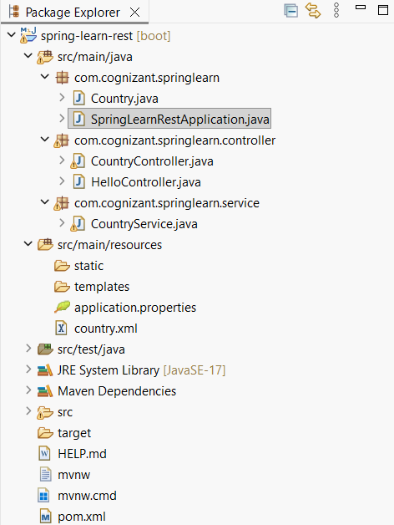

File name : Country.java
package com.cognizant.springlearn;

public class Country {

private String code;
private String name;

public Country() {
}

public Country(String code, String name) {
this.code = code;
this.name = name;
}

public String getCode() {
return code;
}

public void setCode(String code) {
this.code = code;
}

public String getName() {
return name;
}

public void setName(String name) {
this.name = name;
}
}

File name : CountryController.java
package com.cognizant.springlearn.controller;

import org.springframework.beans.factory.annotation.Autowired;
import org.springframework.context.support.ClassPathXmlApplicationContext;
import org.springframework.web.bind.annotation.GetMapping;
import org.springframework.web.bind.annotation.PathVariable;
import org.springframework.web.bind.annotation.RequestMapping;
import org.springframework.web.bind.annotation.RestController;

import com.cognizant.springlearn.Country;
import com.cognizant.springlearn.service.CountryService;

@RestController
public class CountryController {

@Autowired
private CountryService countryService;

// Previous Hands-on
@RequestMapping("/country")
public Country getCountryIndia() {

ClassPathXmlApplicationContext context =
new ClassPathXmlApplicationContext("country.xml");

Country country = context.getBean("country", Country.class);

context.close();

return country;
}

// Current Hands-on
@GetMapping("/countries/{code}")
public Country getCountry(@PathVariable String code) {
return countryService.getCountry(code);
}
}

File name : CountryService.java
package com.cognizant.springlearn.service;
import java.util.List;
import org.springframework.context.ApplicationContext;
import org.springframework.context.support.ClassPathXmlApplicationContext;
import org.springframework.stereotype.Service;

import com.cognizant.springlearn.Country;

@Service
public class CountryService {
public Country getCountry(String code) {
ApplicationContext context = new ClassPathXmlApplicationContext("country.xml");

@SuppressWarnings("unchecked")
List<Country> countryList = (List<Country>) context.getBean("countryList");
for (Country country : countryList) {
if (country.getCode().equalsIgnoreCase(code)) {
return country;
}
}
return null;
}
}

File name : country.xml
<?xml version="1.0" encoding="UTF-8"?>

<beans xmlns="http://www.springframework.org/schema/beans"
xmlns:xsi="http://www.w3.org/2001/XMLSchema-instance"
xsi:schemaLocation="
http://www.springframework.org/schema/beans
https://www.springframework.org/schema/beans/spring-beans.xsd">

<!-- Previous Hands-on -->
<bean id="country" class="com.cognizant.springlearn.Country">
<property name="code" value="IN"/>
<property name="name" value="India"/>
</bean>

<!-- Current Hands-on -->
<bean id="countryList" class="java.util.ArrayList">
<constructor-arg>
<list>

<bean class="com.cognizant.springlearn.Country">
<property name="code" value="IN"/>
<property name="name" value="India"/>
</bean>

<bean class="com.cognizant.springlearn.Country">
<property name="code" value="US"/>
<property name="name" value="United States"/>
</bean>

<bean class="com.cognizant.springlearn.Country">
<property name="code" value="DE"/>
<property name="name" value="Germany"/>
</bean>

<bean class="com.cognizant.springlearn.Country">
<property name="code" value="FR"/>
<property name="name" value="France"/>
</bean>

</list>
</constructor-arg>
</bean>

</beans>

File name : SpringLearnRestApplication.java
package com.cognizant.springlearn;

import org.springframework.boot.SpringApplication;
import org.springframework.boot.autoconfigure.SpringBootApplication;

@SpringBootApplication
public class SpringLearnRestApplication {

public static void main(String[] args) {
SpringApplication.run(SpringLearnRestApplication.class, args);
}

}
Output :
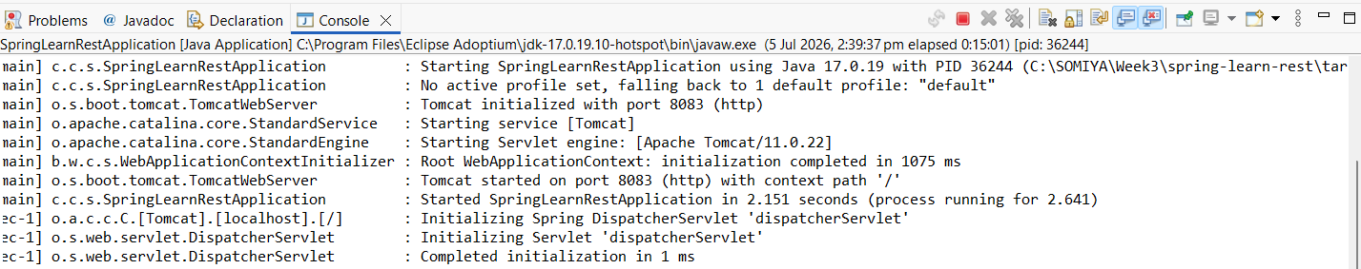

Browser Output :
